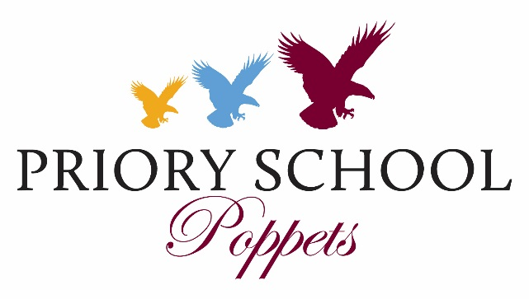

Fees 2022 - 2023

Poppets (Ages 6 Months to 3 Years) Fees Per Term

 | Term Time Only  3 Terms per Annum |  |  | 51 Weeks  3 Terms plus Holidays |  |  | Extra Days  (per day) *
Times & Number of Days | 3 | 4 | 5 | 3 | 4 | 5
 | £ | £ | £ | £ | £ | £ | £
8am-6pm | 2,414 | 3,219 | 4,024 | 3,235 | 4,191 | 5,238 | 70
8.30am-3.15pm | 1,762 | 2,349 | 2,936 | 2,184 | 2,829 | 3,536 | 60
Lunch | £141 | £188 | £235 | £190 | £253 | £316

15 FREE HOURS – THREE and FOUR YEAR OLD CHILDREN
Priory Poppets offers fifteen free hours per week quality care to three and four year old children. Fees are payable for the remaining hours as detailed below.
All places are subject to availability and to minimum attendance three days per week.
The table incorporates further discounts for attendance on four and five days per week.

Nursery (Ages 3 – 4 Years) Fees Per Term
 | Term Time Only  3 Terms per Annum |  |  | 51 Weeks  3 Terms plus Holidays |  |  | Extra Days  (per day) *
Times & Number of Days | 3 | 4 | 5 | 3 | 4 | 5
 | £ | £ | £ | £ | £ | £ | £
8am-6pm | 1,207 | 2,012 | 2,817 | 2,030 | 3,020 | 4,067 | 70
8.30am-3.15pm | 457 | 1,044 | 1,631 | 979 | 1,658 | 2,365 | 60
Lunch | £141 | £188 | £235 | £190 | £253 | £316

* If a child is registered to attend either 3 or 4 days but requires an additional day, they will be charged at the
extra day rate.

Morning Care and After School Care Charges (per session)
8.00 am - 8.30 am | £6.15
3.30 pm - 4.30 pm | £7.25
3.30 pm - 6.00 pm | £12.00
After 6.00 pm | Not available  (£25 charge if child collected later than 6pm)

New Starters
- For all new starters there will be a non-refundable Registration Fee of £50.
- A deposit will be payable for all new pupils.
- £150 of the total deposit is an Acceptance Fee, to cover administrative costs. The remainder will be refunded against the fees of the last term in which the child is due to leave the School, or will be held against any amounts outstanding.

 | Total Payable | Refundable Deposit | Non-Refundable Acceptance Fee
Poppets | £350 | £200 | £150

Sibling Allowances
- Where a child has a brother or sister in the school an allowance of 5% will be made against the younger child’s fees.
- Where a child has two other siblings in the school an allowance of 5% will be made against the youngest child’s fees and 10% against the second youngest. Any allowance is subject to satisfactory payment of fees.

No of children at School | Sibling allowance | Applied to:
2 | 5% | The younger child
3 | 5%  10% | The youngest child  The second youngest child

Payment of Fees
FEES ARE DUE ON THE FIRST DAY OF EACH TERM*

Acceptable forms of payment include:
- Cheque
- Debit card/Credit card (except American Express)
- Bank transfer (see bank details on fee invoice)
- Childcare Vouchers or through ‘Tax Free Childcare’

Paying by Instalments
- We offer a payment scheme with an independent company, School Fee Plan (SFP), under which fees can be paid in four monthly instalments per term, subject to SFP service charges of 2.99%
- For details and application form, please visit our website www.prioryschool.net

* A SURCHARGE OF 15% MAY BE IMPOSED ON OVERDUE ACCOUNTS
PM 11/07/22

